Отчет 5

Создание и настройка схемы телефонных линий

Цель работы: научиться создавать и настраивать телефонные линии

Ход работы:

1. Создание и настройка малой схемы телефонной линии (Рисунок 1);

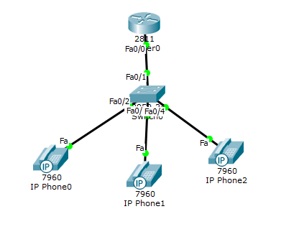

Рисунок 1 – «Малая схема телефонной линии»

1. Проверил, идет ли вызов от одного телефона до другого.
2. Создание большой схемы телефонной линии, состоящей из четырех этажей (Рисунок 2);

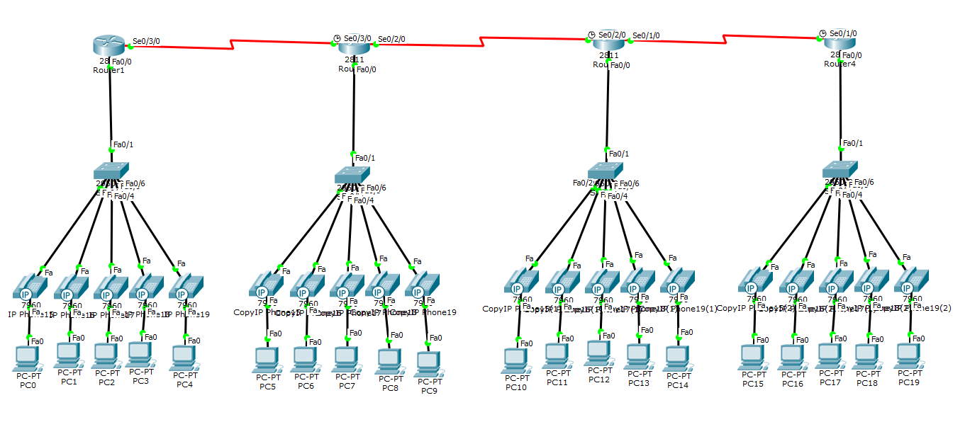

Рисунок 2 – «Создание большой схемы телефонной линии»

1. Настройка большой схемы телефонной линии;
2. Таблица конфигурации подсетей:

|  |  |  |  |  |
| --- | --- | --- | --- | --- |
| **Имя устройства** | **Интерфейс** | **Адрес** | **Маска** | **DNS** |
| PC0-PC4 | Fa0 |  |  | 9.9.9.9 |
| PC5-PC9 | Fa0 |  |  | 2.2.2.2 |
| PC10-PC14 | Fa0 |  |  | 3.3.3.3 |
| PC15-PC10 | Fa0 |  |  | 4.4.4.4 |
| Router1 | Fa0/0  Se0/3/0 | 192.168.10.1  1.1.1.1 | 255.255.255.0  255.255.255.252 |  |
| Router2 | Fa0/0  Se0/3/0  Se0/2/0 | 192.168.20.1  1.1.1.2  1.1.1.5 | 255.255.255.0  255.255.255.252  255.255.255.252 |  |
| Router3 | Fa0/0  Se0/2/0  Se0/1/0 | 192.168.30.1  1.1.1.6  1.1.1.9 | 255.255.255.0  255.255.255.252  255.255.255.252 |  |
| Router4 | Fa0/0  Se0/1/0 | 192.168.40.1  1.1.1.10 | 255.255.255.0  255.255.255.252 |  |

1. Конфигурация роутеров и коммутатора

|  |  |  |  |
| --- | --- | --- | --- |
| Router1 | hostname R1  !  ip dhcp excluded-address 192.168.10.1  !  ip dhcp pool tel  network 192.168.10.0 255.255.255.0  default-router 192.168.10.1  option 150 ip 192.168.10.1  dns-server 9.9.9.9  !  no ip cef  no ipv6 cef  !  spanning-tree mode pvst  !  interface FastEthernet0/0  ip address 192.168.10.1 255.255.255.0  duplex auto  speed auto  !  interface FastEthernet0/1  no ip address  duplex auto  speed auto  shutdown  !  interface Serial0/3/0  ip address 1.1.1.1 255.255.255.252  !  interface Serial0/3/1  no ip address  clock rate 2000000  shutdown  !  interface Vlan1  no ip address  shutdown  !  router rip  version 2  network 1.0.0.0  network 192.168.10.0  !  ip classless  !  ip flow-export version 9  !  dial-peer voice 2 voip  destination-pattern 2..  session target ipv4:1.1.1.2  !  dial-peer voice 3 voip  destination-pattern 3..  session target ipv4:1.1.1.6  !  dial-peer voice 4 voip  destination-pattern 4..  session target ipv4:1.1.1.10  !  telephony-service  max-ephones 5  max-dn 5  ip source-address 192.168.10.1 port 2000  !  ephone-dn 1  number 101  !  ephone-dn 2  number 102  !  ephone-dn 3  number 103  !  ephone-dn 4  number 104  !  ephone-dn 5  number 105  !  ephone 1  device-security-mode none  mac-address 000C.CFEE.D643  type 7960  button 1:1  !  ephone 2  device-security-mode none  mac-address 000C.CFE4.3155  type 7960  button 1:2  !  ephone 3  device-security-mode none  mac-address 0060.5C29.BD83  type 7960  button 1:3  !  ephone 4  device-security-mode none  mac-address 00E0.A348.6766  type 7960  button 1:4  !  ephone 5  device-security-mode none  mac-address 0090.0CAE.5196  type 7960  button 1:5  !  line con 0  !  line aux 0  !  line vty 0 4  login  !  end | Router2 | hostname R2  !  ip dhcp excluded-address 192.168.20.1  !  ip dhcp pool tel  network 192.168.20.0 255.255.255.0  default-router 192.168.20.1  option 150 ip 192.168.20.1  dns-server 2.2.2.2  !  no ip cef  no ipv6 cef  !  spanning-tree mode pvst  !  interface FastEthernet0/0  ip address 192.168.20.1 255.255.255.0  duplex auto  speed auto  !  interface FastEthernet0/1  no ip address  duplex auto  speed auto  shutdown  !  interface Serial0/2/0  ip address 1.1.1.5 255.255.255.252  !  interface Serial0/2/1  no ip address  clock rate 2000000  shutdown  !  interface Serial0/3/0  ip address 1.1.1.2 255.255.255.252  clock rate 2000000  !  interface Serial0/3/1  no ip address  clock rate 2000000  shutdown  !  interface Vlan1  no ip address  shutdown  !  router rip  version 2  network 1.0.0.0  network 192.168.20.0  !  ip classless  !  ip flow-export version 9  !  dial-peer voice 2 voip  destination-pattern 1..  session target ipv4:1.1.1.1  !  dial-peer voice 3 voip  destination-pattern 3..  session target ipv4:1.1.1.6  !  dial-peer voice 4 voip  destination-pattern 4..  session target ipv4:1.1.1.10  !  telephony-service  max-ephones 5  max-dn 5  ip source-address 192.168.20.1 port 2000  !  ephone-dn 1  number 201  !  ephone-dn 2  number 202  !  ephone-dn 3  number 203  !  ephone-dn 4  number 204  !  ephone-dn 5  number 205  !  ephone 1  device-security-mode none  mac-address 0010.1138.ED22  type 7960  button 1:1  !  ephone 2  device-security-mode none  mac-address 000B.BE67.B6C7  type 7960  button 1:2  !  ephone 3  device-security-mode none  mac-address 00D0.FF7E.C359  type 7960  button 1:3  !  ephone 4  device-security-mode none  mac-address 0060.3E34.010E  type 7960  button 1:4  !  ephone 5  device-security-mode none  mac-address 000C.8565.52E4  !  line con 0  !  line aux 0  !  line vty 0 4  login  !  end |
| Router3 | hostname R3  !  ip dhcp excluded-address 192.168.30.1  !  ip dhcp pool tel  network 192.168.30.0 255.255.255.0  default-router 192.168.30.1  option 150 ip 192.168.30.1  dns-server 3.3.3.3  !  no ip cef  no ipv6 cef  !  spanning-tree mode pvst  !  interface FastEthernet0/0  ip address 192.168.30.1 255.255.255.0  duplex auto  speed auto  !  interface FastEthernet0/1  no ip address  duplex auto  speed auto  shutdown  !  interface Serial0/1/0  ip address 1.1.1.9 255.255.255.252  !  interface Serial0/1/1  no ip address  clock rate 2000000  shutdown  !  interface Serial0/2/0  ip address 1.1.1.6 255.255.255.252  clock rate 2000000  !  interface Serial0/2/1  no ip address  clock rate 2000000  shutdown  !  interface Vlan1  no ip address  shutdown  !  router rip  version 2  network 1.0.0.0  network 192.168.30.0  !  ip classless  !  ip flow-export version 9  !  dial-peer voice 1 voip  destination-pattern 1..  session target ipv4:1.1.1.1  !  dial-peer voice 2 voip  destination-pattern 2..  session target ipv4:1.1.1.5  !  dial-peer voice 4 voip  destination-pattern 4..  session target ipv4:1.1.1.10  !  telephony-service  max-ephones 5  max-dn 5  ip source-address 192.168.30.1 port 2000  !  ephone-dn 1  number 301  !  ephone-dn 2  number 302  !  ephone-dn 3  number 303  !  ephone-dn 4  number 304  !  ephone-dn 5  number 305  !  ephone 1  device-security-mode none  mac-address 0000.0C36.B5EB  type 7960  button 1:1  !  ephone 2  device-security-mode none  mac-address 000C.CF4D.6210  type 7960  button 1:2  !  ephone 3  device-security-mode none  mac-address 0004.9A5D.50A3  type 7960  button 1:3  !  ephone 4  device-security-mode none  mac-address 0050.0F11.49A7  type 7960  button 1:4  !  ephone 5  device-security-mode none  mac-address 000C.CF47.2652  type 7960  button 1:5  !  line con 0  !  line aux 0  !  line vty 0 4  login  !  end | Router4 | hostname R4  !  ip dhcp excluded-address 192.168.40.1  !  ip dhcp pool tel  network 192.168.40.0 255.255.255.0  default-router 192.168.40.1  option 150 ip 192.168.40.1  dns-server 4.4.4.4  !  no ip cef  no ipv6 cef  !  spanning-tree mode pvst  !  interface FastEthernet0/0  ip address 192.168.40.1 255.255.255.0  duplex auto  speed auto  !  interface FastEthernet0/1  no ip address  duplex auto  speed auto  shutdown  !  interface Serial0/1/0  ip address 1.1.1.10 255.255.255.252  clock rate 2000000  !  interface Serial0/1/1  no ip address  clock rate 2000000  shutdown  !  interface Vlan1  no ip address  shutdown  !  router rip  version 2  network 1.0.0.0  network 192.168.40.0  !  ip classless  !  ip flow-export version 9  !  dial-peer voice 1 voip  destination-pattern 1..  session target ipv4:1.1.1.1  !  dial-peer voice 2 voip  destination-pattern 2..  session target ipv4:1.1.1.5  !  dial-peer voice 3 voip  destination-pattern 3..  session target ipv4:1.1.1.9  !  telephony-service  max-ephones 5  max-dn 5  ip source-address 192.168.40.1 port 2000  !  ephone-dn 1  number 401  !  ephone-dn 2  number 402  !  ephone-dn 3  number 403  !  ephone-dn 4  number 404  !  ephone-dn 5  number 405  !  ephone 4  device-security-mode none  mac-address 000A.F3B7.06A0  type 7960  button 1:4  !  ephone 1  device-security-mode none  mac-address 000A.4171.C882  type 7960  button 1:1  !  ephone 2  device-security-mode none  mac-address 0060.5C32.357B  type 7960  button 1:2  !  ephone 3  device-security-mode none  mac-address 0001.9791.CE76  type 7960  button 1:3  !  ephone 5  device-security-mode none  mac-address 0002.176D.C0AB  type 7960  button 1:5  !  line con 0  !  line aux 0  !  line vty 0 4  login  !  end |
| Switch6 | hostname Switch  !  spanning-tree mode pvst  !  interface FastEthernet0/1  switchport voice vlan 1  !  interface FastEthernet0/2  switchport voice vlan 1  !  interface FastEthernet0/3  switchport voice vlan 1  !  interface FastEthernet0/4  switchport voice vlan 1  !  interface FastEthernet0/5  switchport voice vlan 1  !  interface FastEthernet0/6  switchport voice vlan 1  !  interface FastEthernet0/7  switchport voice vlan 1  !  interface FastEthernet0/8  switchport voice vlan 1  !  interface FastEthernet0/9  switchport voice vlan 1  !  interface FastEthernet0/10  switchport voice vlan 1  !  interface FastEthernet0/11  switchport voice vlan 1  !  interface FastEthernet0/12  switchport voice vlan 1  !  interface FastEthernet0/13  switchport voice vlan 1  !  interface FastEthernet0/14  switchport voice vlan 1  !  interface FastEthernet0/15  switchport voice vlan 1  !  interface FastEthernet0/16  switchport voice vlan 1  !  interface FastEthernet0/17  switchport voice vlan 1  !  interface FastEthernet0/18  switchport voice vlan 1  !  interface FastEthernet0/19  switchport voice vlan 1  !  interface FastEthernet0/20  switchport voice vlan 1  !  interface FastEthernet0/21  switchport voice vlan 1  !  interface FastEthernet0/22  switchport voice vlan 1  !  interface FastEthernet0/23  switchport voice vlan 1  !  interface FastEthernet0/24  switchport voice vlan 1  !  interface Vlan1  no ip address  shutdown  !  line con 0  !  line vty 0 4  login  line vty 5 15  login  !  end | Switch7 | hostname Switch  !  spanning-tree mode pvst  !  interface FastEthernet0/1  switchport voice vlan 1  !  interface FastEthernet0/2  switchport voice vlan 1  !  interface FastEthernet0/3  switchport voice vlan 1  !  interface FastEthernet0/4  switchport voice vlan 1  !  interface FastEthernet0/5  switchport voice vlan 1  !  interface FastEthernet0/6  switchport voice vlan 1  !  interface FastEthernet0/7  switchport voice vlan 1  !  interface FastEthernet0/8  switchport voice vlan 1  !  interface FastEthernet0/9  switchport voice vlan 1  !  interface FastEthernet0/10  switchport voice vlan 1  !  interface FastEthernet0/11  switchport voice vlan 1  !  interface FastEthernet0/12  switchport voice vlan 1  !  interface FastEthernet0/13  switchport voice vlan 1  !  interface FastEthernet0/14  switchport voice vlan 1  !  interface FastEthernet0/15  switchport voice vlan 1  !  interface FastEthernet0/16  switchport voice vlan 1  !  interface FastEthernet0/17  switchport voice vlan 1  !  interface FastEthernet0/18  switchport voice vlan 1  !  interface FastEthernet0/19  switchport voice vlan 1  !  interface FastEthernet0/20  switchport voice vlan 1  !  interface FastEthernet0/21  switchport voice vlan 1  !  interface FastEthernet0/22  switchport voice vlan 1  !  interface FastEthernet0/23  switchport voice vlan 1  !  interface FastEthernet0/24  switchport voice vlan 1  !  interface Vlan1  no ip address  shutdown  !  line con 0  !  line vty 0 4  login  line vty 5 15  login  !  end |
| Switch8 | hostname Switch  !  spanning-tree mode pvst  !  interface FastEthernet0/1  switchport voice vlan 1  !  interface FastEthernet0/2  switchport voice vlan 1  !  interface FastEthernet0/3  switchport voice vlan 1  !  interface FastEthernet0/4  switchport voice vlan 1  !  interface FastEthernet0/5  switchport voice vlan 1  !  interface FastEthernet0/6  switchport voice vlan 1  !  interface FastEthernet0/7  switchport voice vlan 1  !  interface FastEthernet0/8  switchport voice vlan 1  !  interface FastEthernet0/9  switchport voice vlan 1  !  interface FastEthernet0/10  switchport voice vlan 1  !  interface FastEthernet0/11  switchport voice vlan 1  !  interface FastEthernet0/12  switchport voice vlan 1  !  interface FastEthernet0/13  switchport voice vlan 1  !  interface FastEthernet0/14  switchport voice vlan 1  !  interface FastEthernet0/15  switchport voice vlan 1  !  interface FastEthernet0/16  switchport voice vlan 1  !  interface FastEthernet0/17  switchport voice vlan 1  !  interface FastEthernet0/18  switchport voice vlan 1  !  interface FastEthernet0/19  switchport voice vlan 1  !  interface FastEthernet0/20  switchport voice vlan 1  !  interface FastEthernet0/21  switchport voice vlan 1  !  interface FastEthernet0/22  switchport voice vlan 1  !  interface FastEthernet0/23  switchport voice vlan 1  !  interface FastEthernet0/24  switchport voice vlan 1  !  interface Vlan1  no ip address  shutdown  !  line con 0  !  line vty 0 4  login  line vty 5 15  login  !  end | Switch9 | hostname Switch  !  spanning-tree mode pvst  !  interface FastEthernet0/1  switchport voice vlan 1  !  interface FastEthernet0/2  switchport voice vlan 1  !  interface FastEthernet0/3  switchport voice vlan 1  !  interface FastEthernet0/4  switchport voice vlan 1  !  interface FastEthernet0/5  switchport voice vlan 1  !  interface FastEthernet0/6  switchport voice vlan 1  !  interface FastEthernet0/7  switchport voice vlan 1  !  interface FastEthernet0/8  switchport voice vlan 1  !  interface FastEthernet0/9  switchport voice vlan 1  !  interface FastEthernet0/10  switchport voice vlan 1  !  interface FastEthernet0/11  switchport voice vlan 1  !  interface FastEthernet0/12  switchport voice vlan 1  !  interface FastEthernet0/13  switchport voice vlan 1  !  interface FastEthernet0/14  switchport voice vlan 1  !  interface FastEthernet0/15  switchport voice vlan 1  !  interface FastEthernet0/16  switchport voice vlan 1  !  interface FastEthernet0/17  switchport voice vlan 1  !  interface FastEthernet0/18  switchport voice vlan 1  !  interface FastEthernet0/19  switchport voice vlan 1  !  interface FastEthernet0/20  switchport voice vlan 1  !  interface FastEthernet0/21  switchport voice vlan 1  !  interface FastEthernet0/22  switchport voice vlan 1  !  interface FastEthernet0/23  switchport voice vlan 1  !  interface FastEthernet0/24  switchport voice vlan 1  !  interface Vlan1  no ip address  shutdown  !  line con 0  !  line vty 0 4  login  line vty 5 15  login  !  end |

1. Проверка на наличие связи между телефонами внутри одного из этажей и между этажами (Рисунок 3-4).

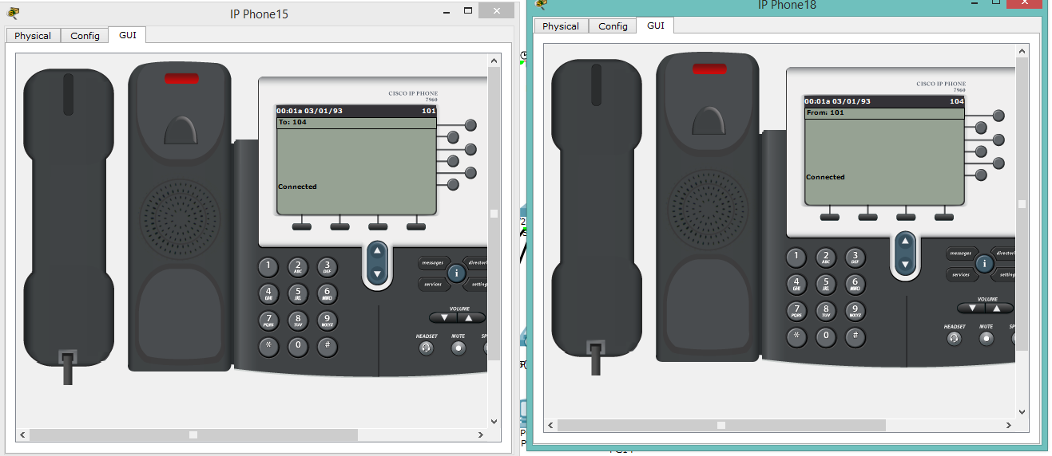

Рисунок 3 – «Проверка связи на одном из этажей»

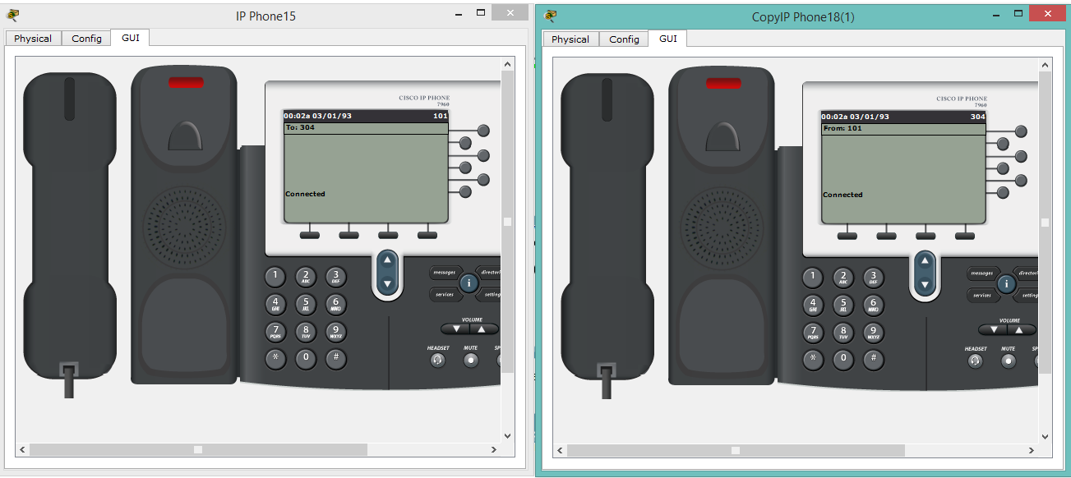

Рисунок 4 – «Проверка связи между первым и третьим этажом»

Вывод: я научился создавать, а также настраивать телефонную сеть с использованием IP телефонии.